PAper title

First author's first name and family name
First author's affiliation, City, Country
first author's e-mail address

Second author's first name and family name
Second author's affiliation, City, Country

Third author's first name and family name
Second author's affiliation, City, Country

Abstract
The abstract should be at least 150 words, but not exceeding one A4 page. The length of the full paper is expected to be between 8-15 pages (without abstract and reference list).
Please submit your paper to the conference e-mail address:
phdconference@eco.u-szeged.hu

KEY WORDS
Maximum of 7 keywords

INTRODUCTION

The expected length of the paper is 10-15 pages.

SECOND EPIGRAPH

Subepigraph 1 (if necessary)

Independent Text

Subepigraph 2 (if necessary)

Independent Text

THIRD EPIGRAPH

Subepigraph 1 (if necessary)

Independent Text

Subepigraph 2 (if necessary)

Independent text with a footnote

LAST EPIGRAPH - CONCLUSIONS
Use as many epigraphs and subepigraphs as required. However, we suggest naming the first epigraph “Introduction” and the last one “Conclusions”.

Here is an example of dotted list:
- This is the suggested dotted list presentation. Dots are used at the beginning of each element of the list. Indentation of 0.5 cm. left and first-line indentation of 0.45 cm.
- Second element of the dotted list.
- Third element.

Here is an example of a Table:

Table 1: Table title (data or text table)
 | Calibri 11 | Calibri 11 | Calibri 11 | Calibri 11
Calibri 11 | Calibri 11 | Calibri 11 | Calibri 11 | Calibri 11
Calibri 11 | Calibri 11 | Calibri 11 | Calibri 11 | Calibri 11
Source: xxxxxxxx

Here is an example of a Figure:

Figure 1: Title of the Figure (figures, graphs, maps, etc.)
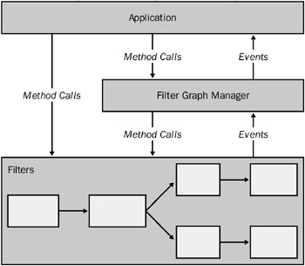
Source: xxxxx

REFERENCES
When citing references intext, we suggest to do so:
This view has been supported in the work of Cormack (1994).
Cormack (1994, pp.32-33) states that 'when writing for a professional readership, writers invariably make reference to already published works'.
The paper should finish with a reference list that must be presented under the title “References”, without numbering.
Reference list entries should be alphabetized by the last names of the first author of each work.

Journal article:
Perry, C., 2001. What health care assistants know about clean hands. Nursing Times, 97(22), pp.63-64.

Book:
Barker, R. Kirk, J. and Munday, R.J., 1988. Narrative analysis. 3rd ed. Bloomington: Indiana University Press.

Chapters from edited books:
Smith, J., 1975. A source of information. In: W. Jones, ed. 2000. One hundred and one ways to find information about health. Oxford: Oxford University Press. Ch. 2.

Online document:
Boughton, J.M., 2002. The Bretton Woods proposal: an in depth look. Political Science Quarterly [e-journal] 42 (6) Available through: Blackwell Science Synergy database [Accessed 12 June 2005]

This is the style for footnotes (Calibri 9-point font)

